**GRAPHIC ART INDUSTRIES**

**Submitted**

**By**

**SUHAS S**

**BU21EECE0200034**

**Under the Guidance of**

**ROHAN PRASAD**

**Duration: 02/12/2024 to 10/03/2025**



**Department of Electrical, Electronics and Communication Engineering**

**GITAM School of Technology**

**GITAM**

**(DEEMED TO BE UNIVERSITY)**

**(Estd. u/s 3 of the UGC act 1956)**

**NH 207, Nagadenehalli, Doddaballapur taluk, Bengaluru-561203 Karnataka, INDIA.**

**DECLARATION**

**I declare that the project work contained in this report is original and it has been done by me under the guidance of my project guide.**

**Name:**

**Date: Signature of the Student**

**Department of Electrical, Electronics and Communication Engineering**

**GITAM School of Technology, Bengaluru-561203**

**CERTIFICATE**

**This is to certify that Suhas S bearing BU21EECE0200034 has satisfactorily completed Mini Project Entitled in partial fulfillment of the requirements as prescribed by University for VIIIth semester, Bachelor of Technology in “Electrical, Electronics and Communication Engineering” and submitted this report during the academic year 2024-2025.**

**[Signature of the Guide] [Signature of HOD]**

**Table of contents**

**Chapter 1: Introduction 5**

1.1 Overview of the problem statement

1.2 Objectives and goals

**Chapter 2 : Graphic Art Industries 7**

2.1 Introduction

2.2 Printing Types

2.3 Process of Printing

**Chapter 3 : Challenges in Die Cutting 14**

3.1 conventional Die Cutting method

3.2 Need for 6mm + 1 mm Counter plate

**Chapter 4 : Design and Implementation 16**

4.1 Design of such a system

4.2 Production as per the new design

4.3 Implementation of the developed design

**Chapter 5 :Results 24**

5.1 Trial runs

5.2 Result

**Chapter 1: Introduction**

**1.1 Overview of the problem**

In the current punching bed setup, a **7 mm thick support plate (Counter Plate)** is required for each job to ensure stability and accuracy during the punching process. However, this system presents several challenges, including **high material consumption, increased storage requirements, and higher production costs**. Since each job demands a dedicated Counter Plate, the number of plates must match the number of jobs, leading to excessive material usage and procurement expenses. Additionally, storing and handling a large number of plates require significant space and organization, adding to operational inefficiencies. The dependency on individual plates for every job also limits flexibility, as each new job necessitates a separate Counter Plate, increasing setup time and slowing down the production process. This not only affects productivity but also contributes to overall workflow inefficiencies. To address these issues, a more **cost-effective and adaptable** approach is needed to optimize resource utilization, reduce waste, and enhance production efficiency. Implementing a reusable, standardized, or adaptable support system could significantly streamline operations while maintaining the required precision and quality in the punching process.

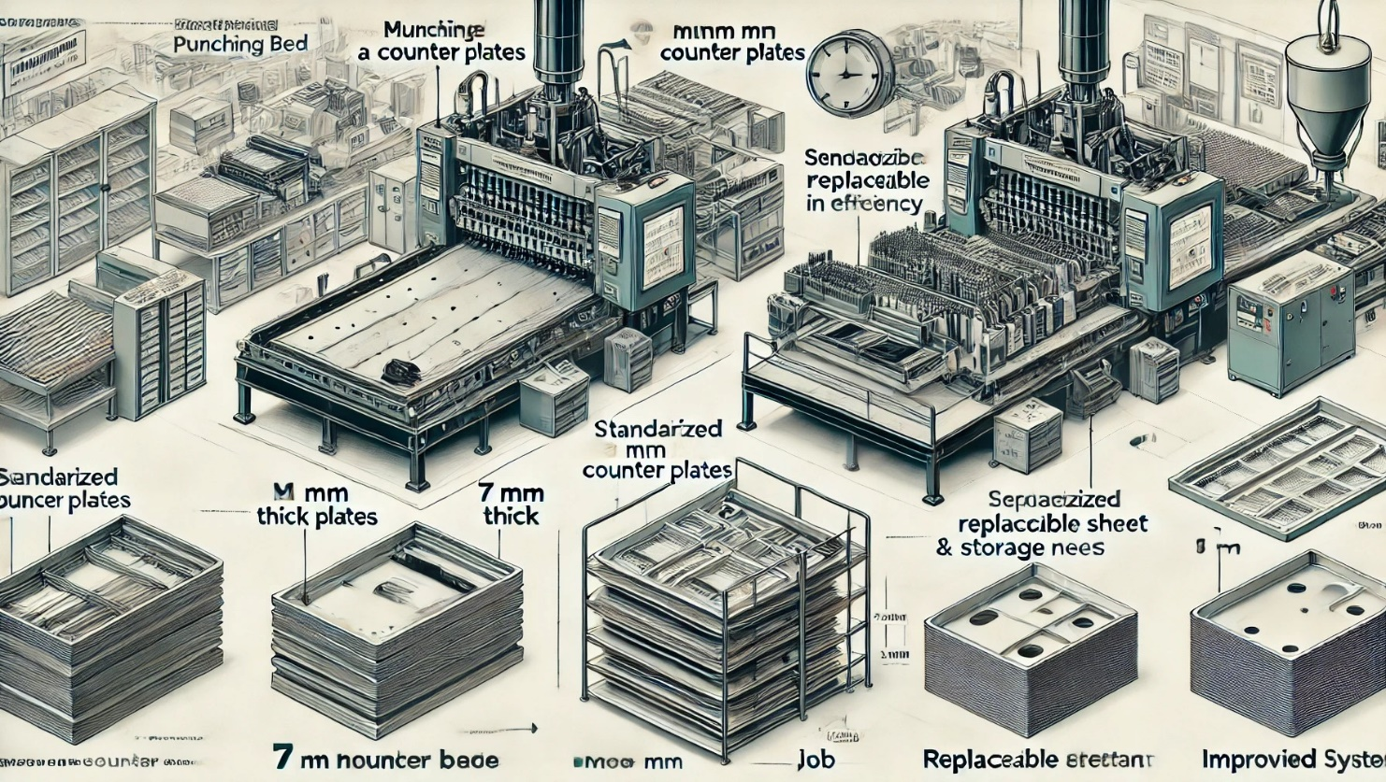

**1.2 Objectives and goals**

|  |  |  |
| --- | --- | --- |
| SI NO | ACTIVITY | STATUS |
| 1 | Understanding the Process of Printing, Die Cutting and Folding Operations in a Packaging Industry | ☑ |
| 2 | Customer Visits | ☑ |
| 3 | Gaining the knowledge of the process of Die Cutting | ☑ |
| 4 | Challenges in the conventional Die Cutting method (use of 7 MM Counter plate) | ☑ |
| 5 | Need for 6mm + 1 mm Counter plate (Advantages) | ☑ |
| 6 | Design of such a system - Study the part, design the parts | ☑ |
| 7 | Production as per the new design | ☑ |
| 8 | Implementation of the developed design | ☑ |
| 9 | Trial runs | ☑ |
| 10 | Results | ☑ |

The objectives of this study focus on understanding and optimizing key processes in the packaging industry. The first objective is to gain a comprehensive understanding of **printing, die-cutting, and folding operations**, which are essential steps in the production of packaging materials. Additionally, detailed knowledge of the **die-cutting process** is acquired to improve efficiency and precision in production. A significant aspect of the study involves evaluating the **need for a 6mm + 1mm counter plate**, analyzing its advantages over conventional methods in terms of durability, cost-effectiveness, and performance. Further, production is carried out **as per the new design**, ensuring that modifications and improvements are implemented effectively. Finally, **trial runs** are conducted to validate the new setup, ensuring that the proposed changes lead to improved operational efficiency and desired outcomes.

**Chapter 2 : Graphic Art Industries**

**2.1 Introduction**

**Graphic Art Industries: An Overview**

The **Graphic Art Industry** is a diverse and dynamic field that focuses on visual communication, creativity, and technical expertise. It plays a significant role in various sectors, including **printing, packaging, advertising, publishing, and digital media**. With advancements in technology, the industry has expanded to include digital design, interactive graphics, and multimedia applications.

**Key Areas of the Graphic Art Industry**

1. **Printing & Packaging** – This sector involves the mass production of printed materials such as **magazines, newspapers, book covers, posters, labels, and product packaging**. Various printing techniques, including **offset printing, digital printing, flexography, and screen printing**, are used depending on the application. The packaging industry, in particular, relies on **graphic art for designing attractive and informative labels, cartons, and wrappers**, ensuring both functionality and brand appeal.
2. **Typography & Calligraphy** – Typography is the art of arranging letters and text in a visually appealing manner, while calligraphy focuses on decorative writing. Both are essential for **branding, advertisements, books, and digital media**. In today’s digital world, **custom fonts and typographic compositions** help brands establish a unique identity and enhance readability in both print and digital formats.
3. **Photography & Digital Imaging** – High-quality images are essential for **advertising, editorial content, web design, and product marketing**. Professional photography, combined with **digital image manipulation, retouching, and compositing**, ensures visually engaging content. In industries such as fashion, food, and e-commerce, well-designed images help in capturing the audience’s attention and influencing consumer behaviour.
4. **Computer Graphics & Multimedia** – This area includes **graphic design, 3D modeling, animation, and visual effects (VFX)**, widely used in film production, video games, web design, and social media marketing. The use of **software such as Adobe Photoshop, Illustrator, CorelDRAW, Blender, and After Effects** has revolutionized graphic design, allowing artists to create intricate and highly detailed visuals. Motion graphics and interactive media also play a vital role in digital marketing and branding strategies.
5. **Advertising & Branding** – The success of a brand heavily depends on its **visual identity**, which includes **logos, business cards, brochures, posters, banners, and social media graphics**. Effective branding ensures **strong customer recognition and loyalty**. Advertisements use **color psychology, design principles, and strategic placement of elements** to influence consumer perception and engagement.
6. **Book & Editorial Design** – Graphic artists contribute to the **layout and visual presentation of books, magazines, newspapers, and online publications**. They ensure the proper use of fonts, images, and white space to **enhance readability and aesthetic appeal**. Additionally, in the film and television industry, graphic designers create **storyboards** to help directors visualize scenes before production.
7. 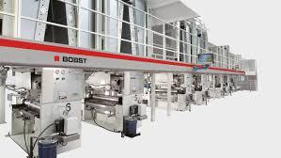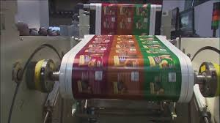**Bindery & Finishing** – Once printed, materials go through the finishing process, which includes **binding, laminating, embossing, foil stamping, and die-cutting**. These finishing touches enhance the **durability, texture, and overall quality of printed products**, making them more appealing to consumers. In packaging, finishing processes such as UV coating and embossing add a **premium look and feel to products**, increasing their market value

**2.2 Printing Types**

### ****Types of Commercial Printing****

Commercial printing involves a variety of techniques, each suited for different types of print products, materials, and production volumes. Below are the most common types of commercial printing methods:

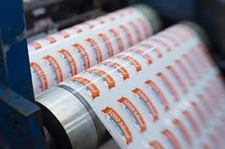

### ****1. Digital Printing****

**Process**: Digital printing transfers images directly from a digital file (such as a PDF or JPEG) onto a printing surface without the use of traditional printing plates.  
**Best for**: Short-run projects, variable data printing (e.g., personalized marketing materials), and on-demand printing.

**Advantages**:

* Fast turnaround time
* Cost-effective for small batches
* Allows customization for each print (e.g., personalized names on brochures)

**Common Uses**: Business cards, flyers, posters, invitations, customized packaging.

### ****2. Screen Printing****

**Process**: Ink is pushed through a mesh stencil (or screen) onto the printing surface. Each color requires a separate screen.  
**Best for**: Printing on non-paper materials such as fabric, glass, wood, and metal.

**Advantages**:

* Vibrant colors with high durability
* Works well on textiles and apparel
* Suitable for large designs and thick ink coverage

**Common Uses**: T-shirts, tote bags, posters, signage, promotional items.

### ****3. LED UV Printing****

**Process**: Uses ultraviolet (UV) light to instantly dry the ink as it is printed, preventing smudging and improving vibrancy.  
 **Best for**: High-quality prints with sharp details, glossy finishes, and minimal environmental impact.

**Advantages**:

* Faster drying times, allowing for quicker production
* Environmentally friendly (no solvent-based inks)
* Resistant to fading and wear

**Common Uses**: Luxury brochures, business cards, magazines, and high-end packaging.

### ****4. Offset Printing****

**Process**: Ink is transferred from a metal plate to a rubber blanket and then to the printing surface.  
 **Best for**: High-volume printing projects requiring consistent color accuracy.

**Advantages**:

* Cost-efficient for bulk printing
* Excellent image quality and color consistency
* Can print on various paper types and finishes

**Common Uses**: Newspapers, books, catalogues, magazines, corporate stationery.

### ****5. Flexographic Printing****

**Process**: Uses flexible rubber plates and fast-drying inks to print on various surfaces, including plastics and metallic films.  
 **Best for**: Printing on packaging materials and continuous printing applications.  
 **Advantages**:

* Works well on uneven or flexible materials
* High-speed production for large orders
* Suitable for food-safe packaging and labels

**Common Uses**: Labels, cartons, plastic bags, flexible packaging, beverage containers

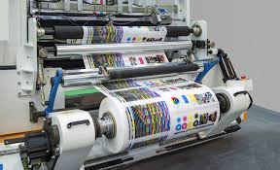

**2.3 Process of Printing**

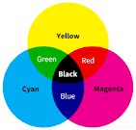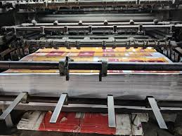

The printing process consists of three key stages: Pre-press, Press, and Post-press. Each stage plays a vital role in ensuring high-quality printed materials with precision and efficiency.

The **Pre-press** stage involves preparing digital files for printing. One of the most widely used technologies in this phase is **Computer-to-Plate (CTP)**, which eliminates the need for traditional film-based plate making. This method directly transfers digital images onto the printing plates, improving accuracy, reducing errors, and enhancing productivity. By using CTP, the overall printing workflow becomes more streamlined and cost-effective.

The **Press** stage is where the actual printing process takes place. The most commonly used color model in printing is **CYMK**, which stands for **Cyan, Magenta, Yellow, and Black**. This combination allows for a wide range of color reproduction. Depending on the design requirements, printing can be done in **4-color (4C), 5-color (5C), or 6-color (6C)** processes, adding more depth and richness to the final output. This stage ensures that the printed material meets the desired color accuracy and vibrancy.

The **Post-press** stage focuses on finishing and enhancing the printed materials. Various processes are involved, including **loop lamination**, which adds a protective layer to improve durability, and **die-cutting**, which is used to shape printed materials into specific forms, such as packaging or labels. Additionally, the **folder-gluer (paste)** process is essential for assembling boxes and other packaging products efficiently. To enhance the aesthetic appeal, **foil stamping** is applied, giving the final product a premium look with metallic or glossy finishes.

Together, these three stages ensure a smooth and efficient printing process, resulting in high-quality, durable, and visually appealing printed materials.

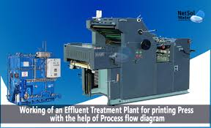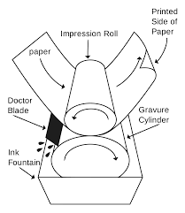

**[Chapter 3 : Challenges in Die Cutting  
  
3.1 conventional Die Cutting method](#_heading=h.2et92p0)** The punching bed in the printing process is equipped with a **7 mm thick support plate**, also known as the **Counter Plate**. This plate serves as a critical component for ensuring precise and efficient punching operations. For each job, a dedicated counter plate must be prepared, meaning that the number of plates required is directly proportional to the number of jobs being handled.

The **size of the counter plate** typically ranges between **1020 mm × 760 mm to 1080 mm × 760 mm**, making them relatively large and heavy. This poses challenges for quick job changeovers and handling. The weight and size of these plates make it difficult to switch between jobs efficiently, often increasing downtime and reducing overall productivity.

Additionally, any damage caused during **handling or job changeovers** necessitates the **replacement of the entire counter plate**. Given the large size and substantial weight of these plates, the **replacement cost is significantly high**[, adding to the operational expenses. Therefore, careful handling and optimized workflow strategies are essential to minimize damage and reduce costs associated with counter plate replacements.  
  
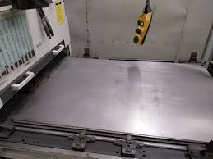](#_heading=h.2et92p0) **3.2Need for 6mm + 1 mm Counter plate**

To improve efficiency and reduce costs, a **6 mm + 1 mm counter plate system** is proposed for the punching bed. In this design, the **6 mm plate** serves as a **permanent fixture** to the bed of the machine, ensuring **stability and durability**. This requires **modifications to the bed** to accommodate the additional layer while maintaining operational effectiveness. The **6 mm plate should be made of high-quality stainless steel** to ensure longevity, as it will be a permanent setup that rarely needs replacement.

On top of the **6 mm stainless steel plate**, a **1 mm counter plate** will be fixed, designed specifically for job-based requirements. This setup necessitates a **new design for both the 6 mm base plate and the 1 mm counter plate**. Unlike the previous system, where each job required a separate heavy counter plate, this new design means that **only the 1 mm plates need to be changed** for different jobs. This drastically reduces the **number of plates required**, making the overall process **more manageable and cost-effective**.

One of the key benefits of this **new counter plate system** is that the **1 mm plates are much lighter**, allowing for **quick job changeovers and easier handling**. This improves **workflow efficiency and reduces downtime** in the production process. Additionally, in the event of **damage during handling or changeovers**, only the **1 mm plate needs to be replaced**, significantly lowering **replacement costs** compared to the previous system where the entire counter plate had to be changed. Overall, this design **[enhances productivity, minimizes material costs, and improves operational flexibility.  
  
  
  
  
  
  
  
  
  
  
  
  
  
  
  
  
Chapter 4 : Design and Implementation  
   
   
 4.1 Design of such a system](#_heading=h.2et92p0)** The new design introduces a 6 mm high-quality stainless steel base plate as a permanent fixture to the machine bed, ensuring long-term stability and reducing the frequency of replacements. To accommodate this modification, necessary adjustments must be made to the machine bed structure. The 6 mm plate will serve as the foundation for the 1 mm counter plates, which will be designed for easy installation and removal. These 1 mm plates will be used specifically for different jobs, meaning that only the required number of counter plates will be maintained. The lightweight nature of the 1 mm plates enhances job changeovers, making the process quicker and more efficient while also reducing manual handling efforts.

A key advantage of this redesign is that in the event of damage caused during handling or changeover, only the 1 mm plate will need to be replaced, significantly lowering maintenance costs compared to previous designs where entire setups had to be changed. Additionally, this new system improves operational efficiency, minimizes downtime, and ensures better durability of the primary fixture. The stainless steel construction of the 6 mm base plate provides superior resistance to wear and tear, making it a cost-effective solution in the long run. Furthermore, the use of standardized counter plates simplifies inventory management and reduces material wastage.

By implementing this new design, the overall productivity of the machine will improve, leading to enhanced workflow and streamlined production processes. The system ensures precision, reliability, and ease of maintenance, making it a practical and economical solution for job handling in industrial applications.

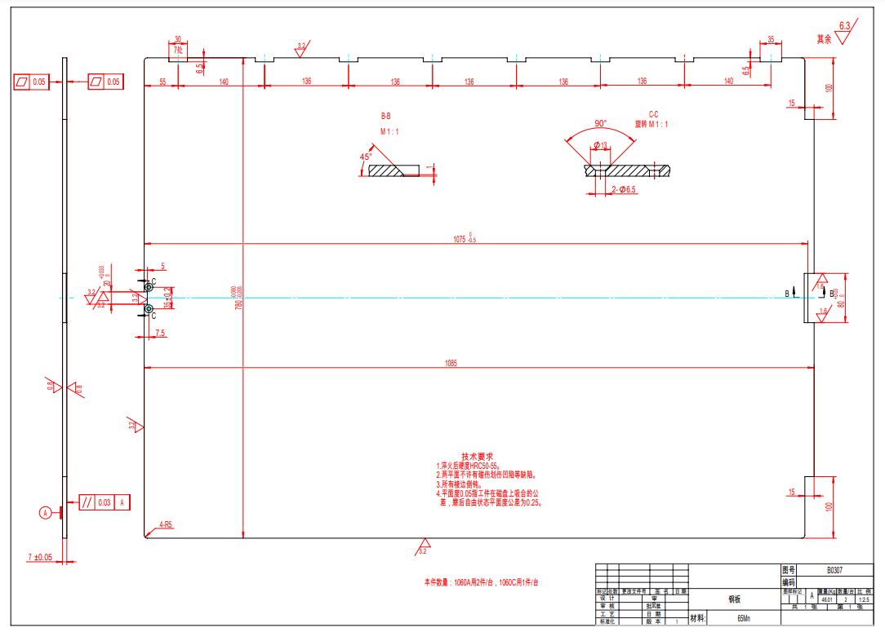

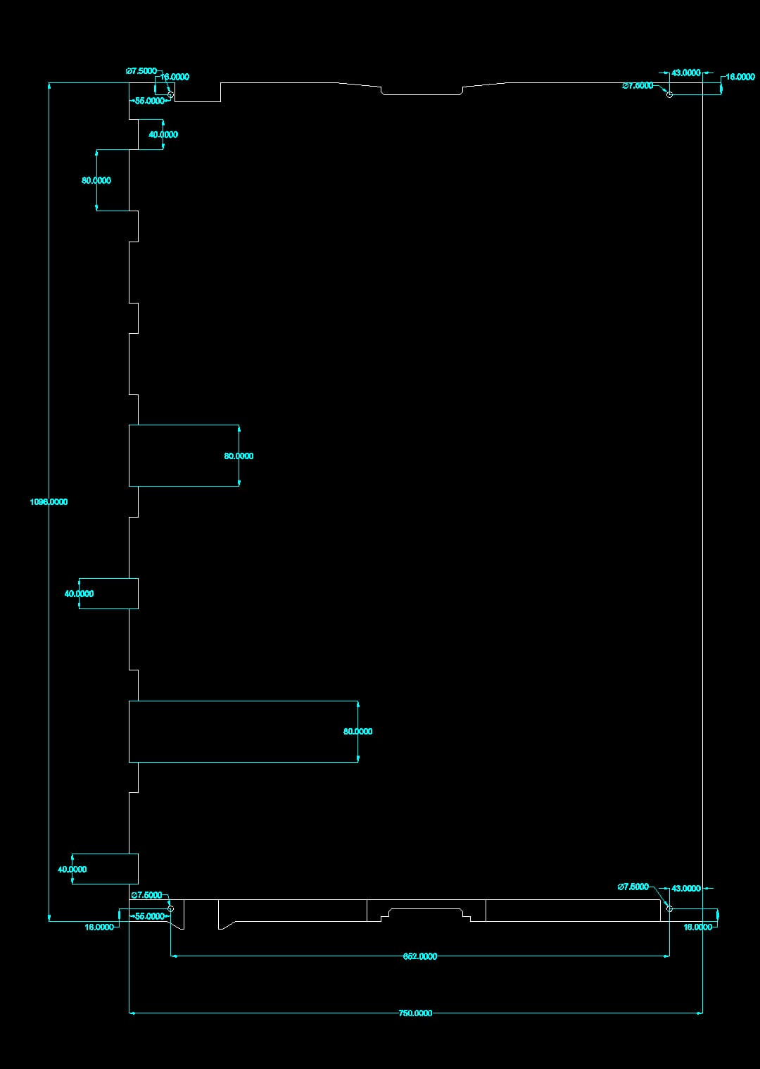

**4.2 Production as per the new design**

**Production as per the New Design**

With the newly designed system in place, the production process will follow a streamlined and efficient approach. Below is the stepwise implementation for manufacturing and integrating the 6 mm base plate and 1 mm counter plates:

### ****1. Conversion of 7 mm Sheet to 6+1 mm System****

* Instead of using a single 7 mm thick plate, the design will be modified to have:
  + **6 mm Permanent Base Plate** (Mounted on the machine bed)
  + **1 mm Replaceable Counter Plate** (Specific to each job)
* This allows flexibility while maintaining the required total thickness.

### ****2. Mounting the 6 mm Sheet on the Machine Bed****

* The **6 mm sheet will be fixed permanently** to the machine bed to provide a solid and stable base.
* It will be installed using bolts, clamps, or a welded setup, depending on machine specifications.
* Surface finishing and leveling will ensure accuracy in operations.

### ****3. Mounting the 1 mm Counter Plate on the 6 mm Base Plate****

* The **1 mm sheet will be placed on top of the 6 mm sheet** without affecting the machine’s core functionality.
* A **quick-fix mechanism** (magnets, clamps, screws, or vacuum hold) will be integrated for easy replacement.
* This setup ensures minimal downtime during job changeovers.

### ****4. Functionality Considerations****

* The **6 mm base plate remains fixed** throughout operations, ensuring long-term stability.
* The **1 mm counter plate is designed per job requirements**, making it **easily replaceable** when needed.
* This modular approach enhances efficiency and reduces material wastage.

### Micro adjustable cutting plates ...

### ****5. Advantages of the 6+1 mm System****

**Cost-Effective** – Only the 1 mm plate needs replacement, reducing material costs.  
 **Easy Job Changeovers** – Dedicated 1 mm plates simplify production shifts.  
 **Improved Machine Life** – Reduces wear on the main machine bed.  
 **Flexible Design** – Adaptable to different job requirements.

### ****6. Attachment Mechanisms for the 1 mm Replaceable Sheet****

* **Magnetic Hold** – If the machine allows, strong magnets can be used for quick attachment and easy removal.
* **Mechanical Clamping** – Adjustable clamps or screws ensure a tight and secure fit.
* **Adhesive/Double-Sided Tape** – In some cases, industrial-grade adhesives can be used for temporary fixation.
* **Vacuum Suction** – If applicable, vacuum-based holding mechanisms can secure the thin sheet without deformation.

### ****7. Ensuring Flatness and Alignment****

* A precision **grinding process** may be required to ensure the 6 mm base remains perfectly level.
* Use of **dowel pins or alignment guides** to prevent misalignment when replacing the 1 mm sheet.
* Regular **inspection and maintenance** to avoid uneven wear on the 6 mm base plate.

### ****8. Material Selection Considerations****

* **6 mm Base Plate:**
  + Should be durable, rigid, and resistant to wear (e.g., **mild steel, hardened steel, or aluminum**).
  + Surface should be treated (e.g., **chrome plating or powder coating**) to prevent corrosion.
* **1 mm Replaceable Sheet:**
  + Material selection depends on the job type (e.g., **stainless steel for corrosion resistance, hardened steel for impact resistance**).
  + Can be coated with **anti-friction or heat-resistant layers** if needed.

### ****9. Practical Implementation in Production****

* Maintain an **inventory of pre-cut 1 mm sheets** for various jobs to reduce downtime.
* Use **barcode or tagging systems** to track and organize different 1 mm sheets per job.
* Introduce **automated loading/unloading mechanisms** for quick sheet replacement.

### ****10. Safety and Operational Efficiency****

* Operators should follow **a standardized replacement procedure** to avoid errors.
* Ensure that **thermal expansion effects** are considered, especially for high-temperature processes.
* If the 1 mm sheet is prone to damage, establish **quality control checks** before every job.  
    
    
  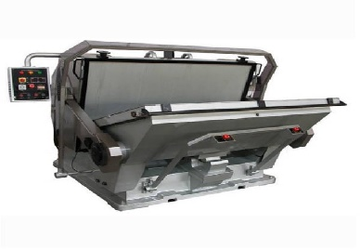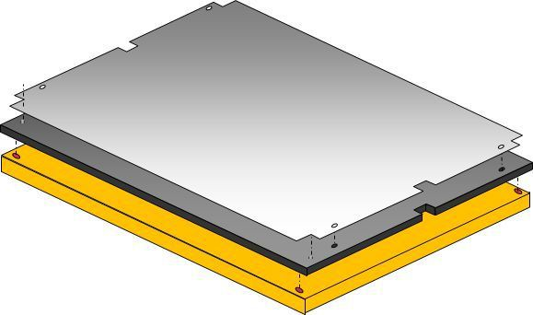

**4.3 Implementation of the developed design**

### ****Implementation of the Developed Design for the 6+1 mm Sheet System****

After finalizing the design of the **6+1 mm sheet system**, the next crucial step is its **implementation** in the production process. Below are the structured steps for smooth execution:

### ****1. Prototype Development and Testing****

* Fabricate a prototype of the **6 mm base plate** using the selected material (e.g., **hardened steel, mild steel, or aluminum**).
* Cut and prepare the **1 mm replaceable sheet** to match the machine’s working area.
* Test different **attachment methods** (e.g., magnetic, clamps, screws) to find the most efficient securing mechanism.
* Conduct **load testing and alignment checks** to ensure that the 1 mm sheet does not shift during operations.

### ****2. Machine and Workstation Preparation****

* Modify existing workstations or machines **to accommodate the 6+1 mm setup**.
* Ensure that the **machine bed is level** to avoid inconsistencies in processing.
* Implement **alignment guides** (e.g., dowel pins or precision slots) to position the 1 mm sheet accurately.
* If necessary, **train operators** on handling, installation, and maintenance of the sheet system.

### ****3. Production Rollout and Integration****

* Begin **small-scale production runs** to validate system efficiency before full deployment.
* Monitor **vibration, heat, and wear effects** on both the base plate and the replaceable sheet.
* Establish a **replacement cycle** for the 1 mm sheets based on job requirements.
* Introduce an **inventory tracking system** to manage and organize different sheets per job.

### ****4. Quality Control and Performance Evaluation****

* Inspect for **flatness and surface wear** after multiple cycles of sheet replacement.
* Conduct **material strength testing** to ensure the 1 mm sheet does not affect job precision.
* Gather **operator feedback** to refine handling and replacement processes.
* If required, optimize the **surface coating** of the base plate for better durability.

### ****5. Full-Scale Implementation and Continuous Improvement****

* Standardize the **installation and replacement procedures** for the 6+1 mm system.
* Implement **automated loading/unloading solutions** to enhance productivity.
* Maintain a **record of performance metrics** such as material usage, job accuracy, and downtime.
* Periodically review the design and **introduce improvements** based on operational feedback.

### ****Expected Benefits of Implementation****

**Reduced Material Waste** – Only the 1 mm sheet needs replacement, reducing overall costs.  
 **Improved Precision** – The 6 mm base ensures stability, while the 1 mm sheet allows for flexible job-specific adjustments.  
 **Enhanced Efficiency** – Faster replacement of sheets results in **minimal downtime** during production.  
 **Long-Term Cost Savings** – Extending the lifespan of the base plate reduces frequent material expenses

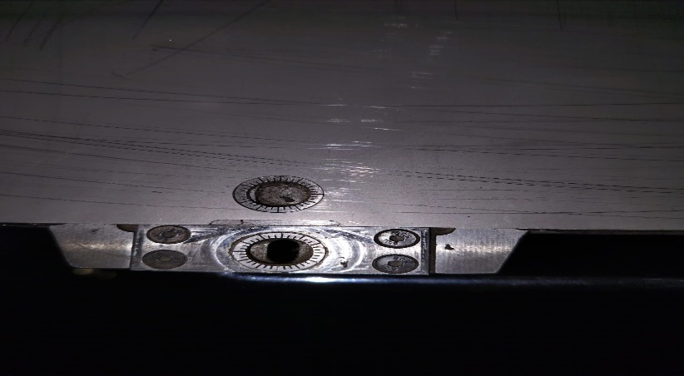 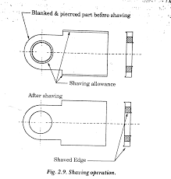

**Chapter 5 :Results  
  
5.1 Trial runs**  
  
Before full-scale implementation, **trial runs** are essential to validate the performance and feasibility of the **6+1 mm sheet system**. This phase helps in identifying potential issues and refining the process for smooth operation.

### ****Objectives of the Trial Runs****

Verify the **stability and accuracy** of the mounted 1 mm sheet on the 6 mm base.  
 Ensure that the **clamping or mounting mechanism** holds the sheet firmly without shifting.  
 Test for **job-specific precision** and alignment across different workpieces.  
 Evaluate **wear and tear** on the 1 mm replaceable sheet after multiple cycles.  
 Analyse **operator handling efficiency** and ease of sheet replacement.

### ****Step-by-Step Execution of Trial Runs****

#### ****1. Setup & Initial Checks****

* Install the **6 mm base plate** securely on the machine bed.
* Mount a **1 mm replaceable sheet** using the selected fastening technique (e.g., screws, magnets, clamps).
* Inspect for **surface flatness and proper alignment** with machine tools.

#### ****2. Trial Job Execution****

* Run a **small batch of production jobs** on the setup to evaluate cutting, machining, or welding efficiency.
* Monitor **thermal expansion, vibrations, and movement** of the 1 mm sheet during operations.
* Check for **defects, misalignment, or any distortion** in the final product.

#### ****3. Wear & Durability Testing****

* Perform **multiple job cycles** on the same sheet to assess longevity.
* Inspect for **scratches, deformations, or material weakening** on the 1 mm sheet.
* Compare results with the **original 7 mm sheet performance** to validate improvements.

#### ****4. Operator Feedback & Adjustments****

* Gather **feedback from operators** regarding ease of sheet replacement and handling.
* Identify any **ergonomic or safety concerns** while working with the new system.
* If necessary, refine **mounting techniques or material selection** based on results.

#### ****5. Final Validation & Approval****

* Document **all observations, improvements, and necessary modifications** from the trial phase.
* If successful, move to **full-scale production implementation**.
* If issues persist, revise the **design or process flow** before re-running tests.

### ****Expected Outcomes from Trial Runs****

**Validated design performance** with precise job execution.  
 **Optimized sheet replacement process** for minimal downtime.  
 **Identified best practices** for mounting and securing sheets.  
 **Confidence in full-scale production rollout** with minimal risks

**5.2 Result**

### ****Industry Knowledge & Optimization****

**Printing & Packaging Expertise Acquired** – The project provided valuable insights into the **printing and packaging** industry, helping optimize **sheet handling and processing techniques**.

**Study of Punching Machines** – A **detailed comparison** of **conventional and modern punching machines** was conducted, leading to an **efficient and upgraded** design approach.

### ****2. Cost-Effective & Efficient Punching Method****

A **cost-effective punching method** was successfully implemented, ensuring reduced material wastage and **optimized job execution**.

The **new 6+1 mm system** eliminates the need for **entire sheet replacement**, **reducing operational costs**.

The **reduced thickness variation** in the sheet setup maintains **accuracy and repeatability**, ensuring **consistent production quality**.

### ****3. Quick Job Changeovers Achieved****

The **1 mm replaceable sheet system** allows for **faster job changeovers**, significantly improving **production efficiency**. Operators experienced **minimal downtime**, increasing overall machine productivity.

The **quick mounting technique** ensures **seamless alignment** without disturbing existing configurations.

### ****4. Scalability of the Developed Method****

The developed **6+1 mm sheet concept** is **not limited** to a single thickness combination. It can be successfully applied to:

* **4+1 mm sheets**
* **5+1 mm sheets**
* **Similar custom thickness variations**

This flexibility allows **broader industrial applications** without requiring major modifications.

### ****Final Conclusion & Next Steps****

The **developed system successfully meets** all performance, cost, and efficiency requirements.  
 The approach is **ready for large-scale implementation** with potential expansion to **other thickness variations**.  
 **Next Step:** Full-scale production rollout and continued refinement based on real-world performance.